# Pin assignment

Go to “Processing” “Start” “Start Analyzes & Elaboration”. After finishing the process go to “Assignment” “Pin Planner”. There you’ll see your inputs and outputs. Assign those inputs and outputs to appropriate pins of your chip.

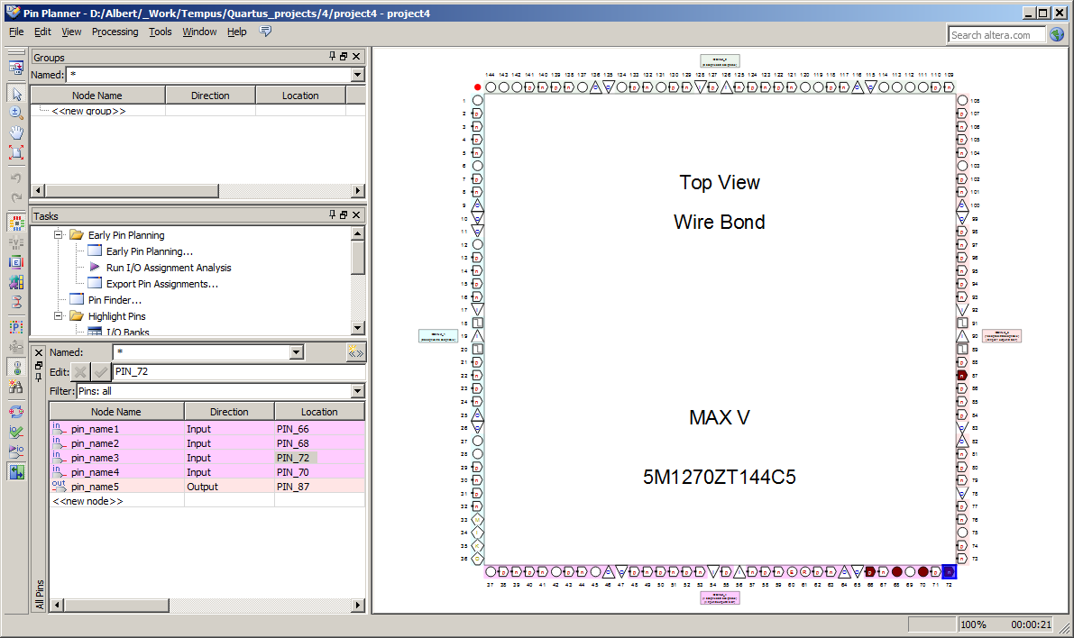

Use the file supplied by Ilmenau University for RPTB – “RPB Pinning.qsf”. There you can see which pin if the chip to which Switch, Button or Indicator is connected. F.E. Using 70 or 72 PIN you use the corresponding Switch on the board

set_location_assignment PIN_72 -to Switch[0]

set_location_assignment PIN_70 -to Switch[1]

Or if you choose PIN_87 then you choose the upper segment of the number LED.

set_location_assignment PIN_87 -to Hex0[0]

set_location_assignment PIN_86 -to Hex0[1]

set_location_assignment PIN_85 -to Hex0[2]

set_location_assignment PIN_93 -to Hex0[3]

set_location_assignment PIN_91 -to Hex0[4]

set_location_assignment PIN_89 -to Hex0[5]

set_location_assignment PIN_88 -to Hex0[6]

set_location_assignment PIN_96 -to Hex0[7]

Go to “Assignment” “Assignment Editor” and see the pin assignment. Here you can manually change the PIN values if you want.

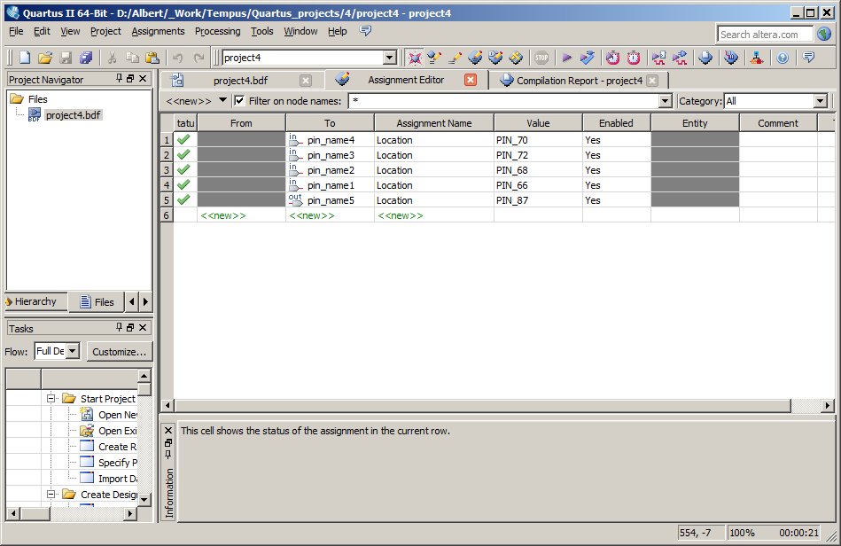

# Rapid prototyping board programming

For using the real rapid prototyping board you need the Quartus project’s output file - *.pof and the executable file to program the board - **IUT RemoteLab CPLD Programmer.exe**

* Connect the board by mini USB cable to the computer where you created your Quartus project.
* Power on the board
* Run **IUT RemoteLab CPLD Programmer.exe.** You’ll see this screen

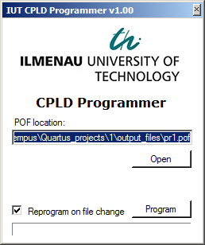

* Press open button and chose your Quartus project’s *.pof file.
* Press “Program” button and wait until the program says “Programming finished”.
* Then the board is ready to work on it. Switch the corresponding switches or push the buttons to see the changes on the indicators.
* If you leave this window opened then in case of you recompile your Quartus project the changes are automatically programmed on the board again.
* MAX V qdz files should be added:
  + During installation
  + After installation (add devices) – by Quartus Device Installer
  + In the program environment by Tools, Options ….
* When connecting the board to computer there should be installed drivers for the board.